Assignment -1
Python Programming

Assignment Date | 19 September 2022
Student Name | Suriya Lekshmi R.M`
Student Roll Number | 310819104086
Maximum Marks | 2 Marks

Question-1:
Write a program which will find all such numbers which are divisible by 7 but are not a multiple of 5, between 2000 and 3200 (both included). The numbers obtained should be printed in a comma-separated sequence on a single line.

Solution:
l=[]
for i in range(2000, 3201):
if (i%7==0) and (i%5!=0):
l.append(str(i))
print (','.join(l))
#----------------------------------------#
#----------------------------------------#
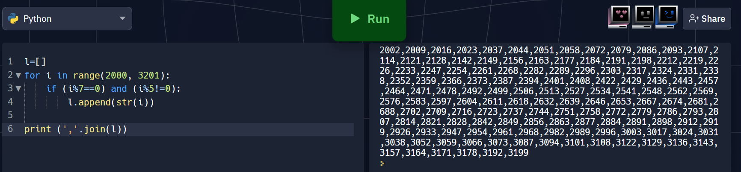

Question-2:
With a given integral number n, write a program to generate a dictionary that contains (i, i*i) such that is an integral number between 1 and n (both included). and then the program should print the dictionary.

Suppose the following input is supplied to the program:
8

Then, the output should be:
{1: 1, 2: 4, 3: 9, 4: 16, 5: 25, 6: 36, 7: 49, 8: 64}

Solution:
n=int(input())
d=dict()
for i in range(1,n+1):
d[i]=i*i
print d
#----------------------------------------#
#----------------------------------------#

